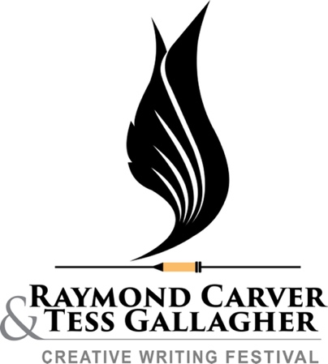

Sally Hedges-Blanquez Scholarship:

Thanks to a generous gift from patron Sally Hedges-Blanquez, we will award one all-access festival pass combined with one writing workshop (a $520 value) as a scholarship for this year’s festival.

To be considered, please email a letter to Michael Mills at: mmills@pencol.edu with Sally Hedges-Blanquez Scholarship in the subject line. Please briefly address each of the criteria listed below in the letter.

Our Criteria:

- The applicant will be able to cover their own travel, housing, and any other associated costs
- The applicant demonstrates a serious interest in Creative Writing
- The applicant includes a brief financial narrative describing the value of the scholarship in their particular economic situation
- The applicant is willing to write a brief thank you letter to the patron after the festival to describe the value of his/her/their experience

We hope to expand scholarship opportunities in the near future.

